**DAILY ONLINE ACTIVITIES SUMMARY**

|  |  |  |  |  |  |  |  |  |
| --- | --- | --- | --- | --- | --- | --- | --- | --- |
| **Date:** | **02-06-2020** | | | | | **Name:** | **SRILATHA K KAMATH** | |
| **Sem & Sec** | **6 B** | | | | | **USN:** | **4AL17CS099** | |
| **Online Test Summary** | | | | | | | | |
| **Subject** | | **Computer graphics and Visualisation** | | | | | | |
| **Max. Marks** | | **30** | | **Score** | | | **30** | |
| **Certification Course Summary** | | | | | | | | |
| **Course** | **Python for Data science** | | | | | | | |
| **Certificate Provider** | | | **Cognitive classes** | | **Duration** | | | **5days** |
| **Coding Challenges** | | | | | | | | |
| **Problem Statement:** Java programs to left rotate the elements of the array and to check whether there exists a loop in a linked list. | | | | | | | | |
| **Status: COMPLETED** | | | | | | | | |
| **Uploaded the report in Github** | | | | | **YES** | | | |
| **If yes Repository name** | | | | | https://github.com/alvas-education-foundation/Srilatha-K-Kamath-Daily-Report.git | | | |
| **Uploaded the report in slack** | | | | | **YES** | | | |

Online Test Details:

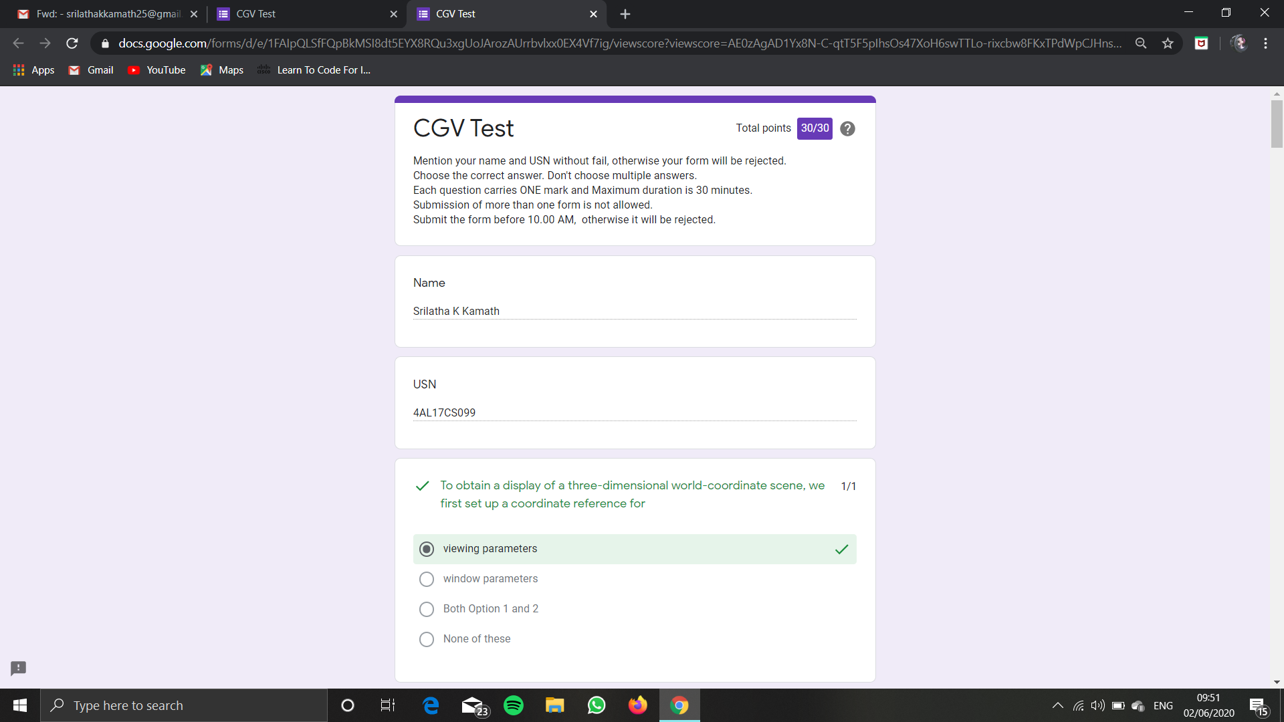

Online Course Details:

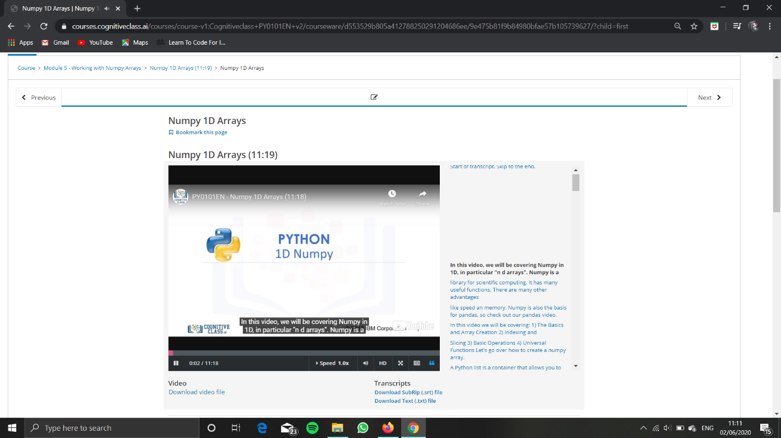

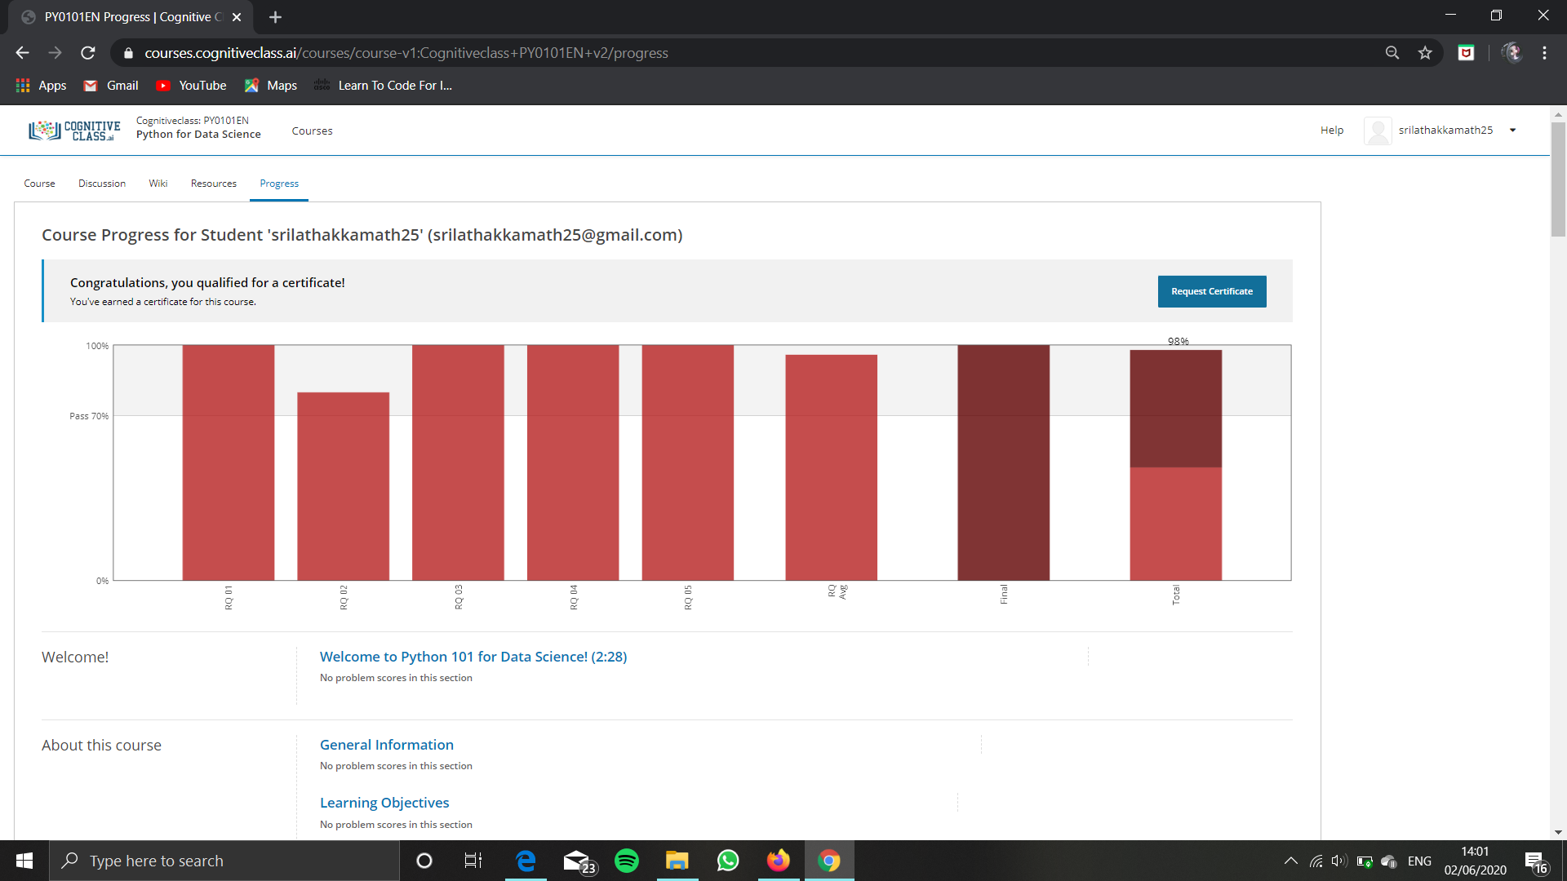

Completed the course “Python for Data science” and obtained a badge and a certificate for the same. Posted both of them in github repository.

Badge:

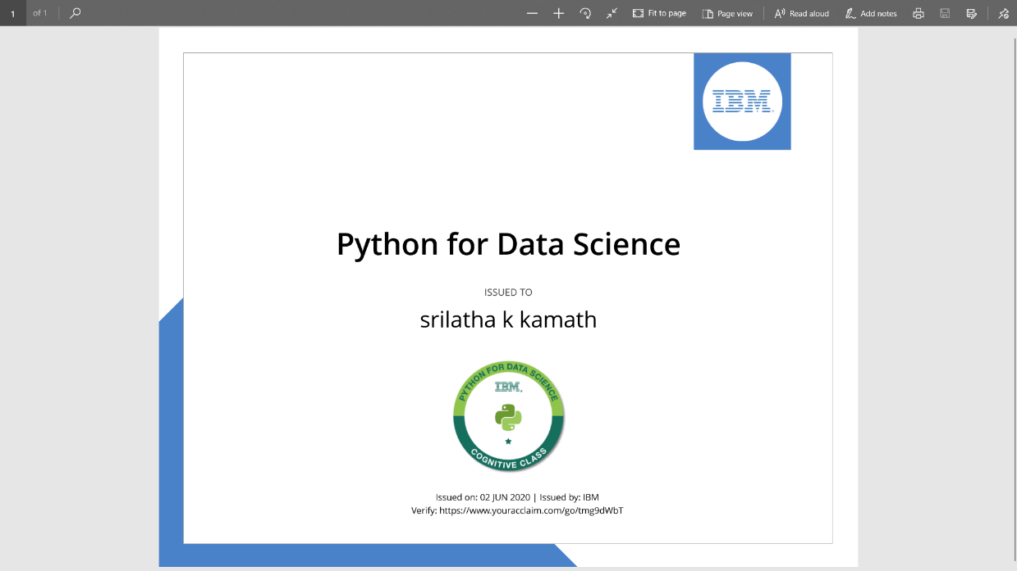

Certificate:

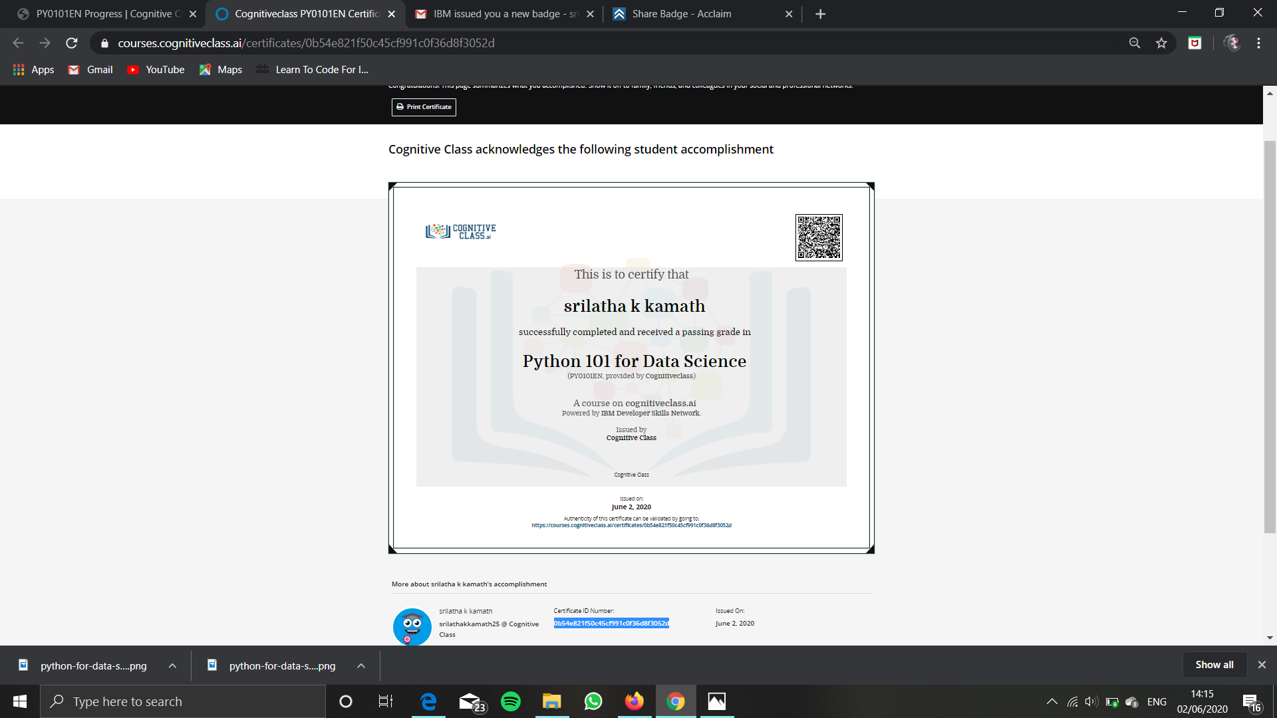

Online Coding Details:

